**Project Proposal - Chipotle: Cultivating a Better World**

Alvin, Arthur, Tiffany, Melissa & Mallory

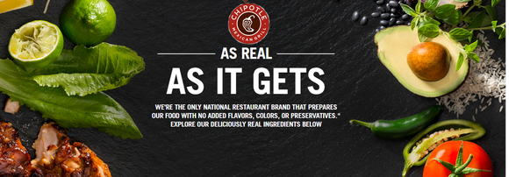

Purpose:

Persuade potential investors to invest in Chipotle Mexican Grill for expansion.

Team Role:

We are the Executives of Sales & Development at Chipotle Mexican Grill Headquarters.

More on Chosen Topic and Rationale:

There is not just a COVID pandemic in the United States right now, but an obesity pandemic. Obesity has become pandemic owing to an obesogenic environment (inexpensive calorie dense food, technologies and structure of communities that reduce or replace physical activity, and inexpensive nonphysical entertainment). A huge factor of this obesogenic environment is the influx of fast-food options across the US.

We, as Chipotle Mexican Grill, find ourselves in a unique space where we provide healthier options compared to the majority of fast food restaurants. Chipotle is leading the charge in healthy fast-food (to curb the obesity pandemic) and is challenging people to change the way that people think about fast food. In our presentation, we will be sharing more on Chipotle’s success and how we are continuing to make a positive impact in our society. We are asking investors to invest in us so that we can continue to grow and cultivate a better world.

Link to GitHub: <https://github.com/drcheerful99/chipotle.git>

Data:

* Fast Food/Chipotle Stock Market Data:
  + *Publicly Traded U.S. Restaurant Chains and Stock Exchange Symbols*

<https://www.thebalancesmb.com/publicly-traded-us-restaurant-chains-2892798>

* All Fast Food Data:
  + *Fast Food Restaurants Across America A list of 10,000 restaurants and their location*

<https://www.kaggle.com/datafiniti/fast-food-restaurants?select=FastFoodRestaurants.csv> –

* Obesity Data:
  + *Obesity and GDP Rates from 50 States in 2014-2017*

<https://www.kaggle.com/annedunn/obesity-and-gdp-rates-from-50-states-in-20142017>

* Chipotle location data:
  + *Chipotle Locations: A CSV file for all Chipotle Locations in the US*

<https://www.kaggle.com/jeffreybraun/chipotle-locations>

<https://www.kaggle.com/jeffreybraun/chipotle-locations?select=us-states.json>

Visual Ideas:

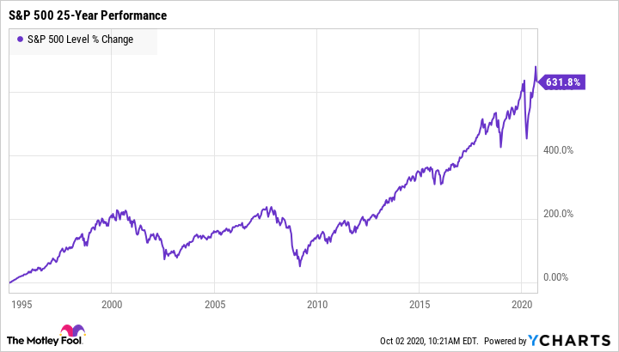

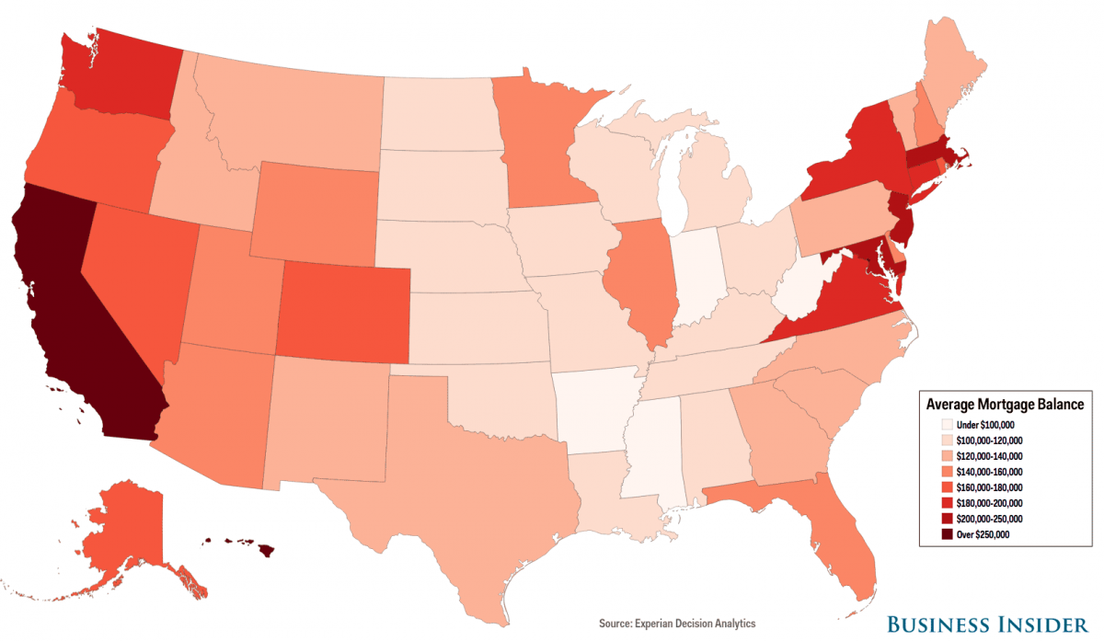

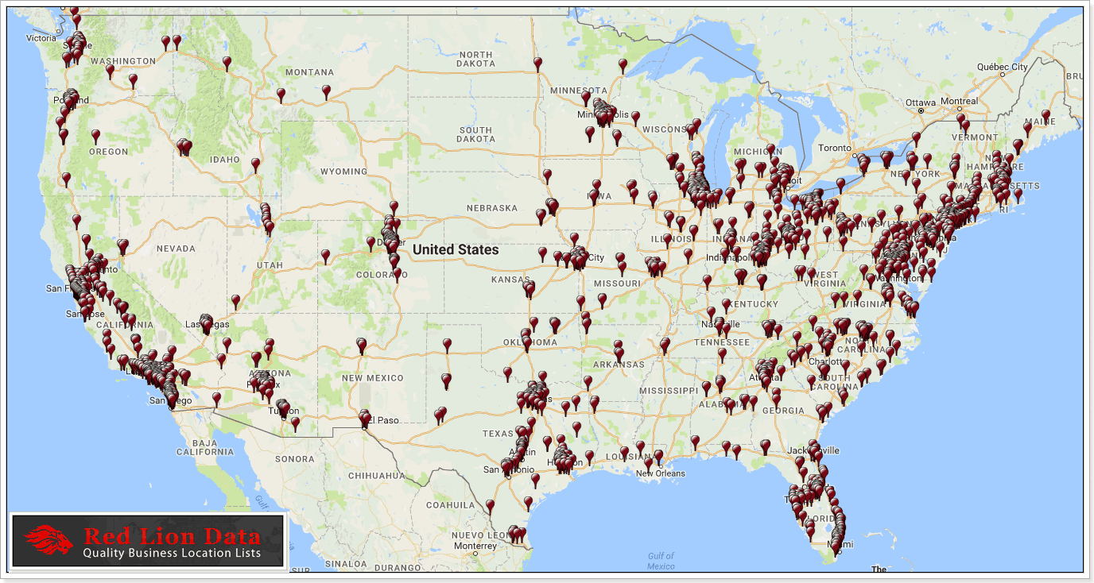

Final Design:

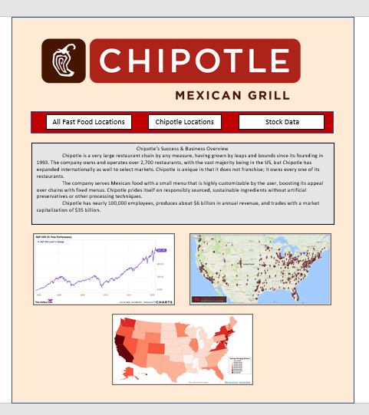



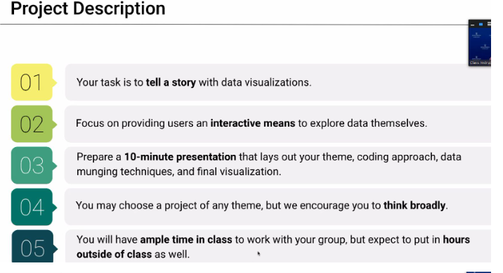

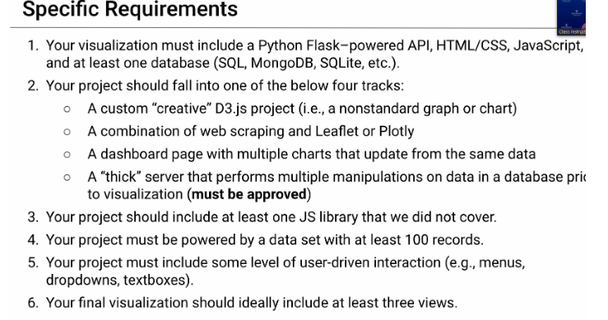

### <https://www.suredividend.com/will-chipotle-ever-pay-a-dividend/>

### ****Business Overview****

Chipotle is a very large restaurant chain by any measure, having grown by leaps and bounds since its founding in 1993. The company owns and operates over 2,700 restaurants, with the vast majority being in the US, but Chipotle has expanded internationally as well to select markets. Chipotle is unique in that it does not franchise; it owns every one of its restaurants.

The company serves Mexican food with a small menu that is highly customizable by the user, boosting its appeal over chains with fixed menus. Chipotle prides itself on responsibly sourced, sustainable ingredients without artificial preservatives or other processing techniques.

Chipotle has nearly 100,000 employees, produces about $6 billion in annual revenue, and trades with a market capitalization of $35 billion.

Chipotle reported its [third quarter earnings](https://ir.chipotle.com/2020-10-21-Chipotle-Announces-Third-Quarter-2020-Results-Q3-Digital-Sales-Tripled-Year-Over-Year-And-Accounted-For-Nearly-Half-Of-Sales) on October 21st, with the report being another smasher by a company that is accustomed to huge success. Total revenue was up 14% year-over-year to $1.6 billion during a time when many restaurants are struggling to match last year’s levels. Comparable sales were responsible for over half of the total revenue gain at 8.3%, with the balance coming from new stores. The company added 44 new stores and closed three during the period, and noted that it still had 10 stores that were closed from COVID-19.

Digital sales grew more than 200% and accounted for almost half of total revenue during the quarter, solidifying the fact that Chipotle is the undisputed leader in the restaurant space when it comes to digital channels. Earnings-per-share fell 1.6% year-over-year to $3.76 as operating margins declined slightly, but overall, investors cheered the report.